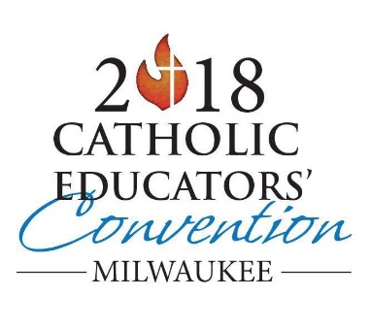

Archdiocese of Milwaukee
2018 Catholic Educators’ Convention
Wisconsin Center, Milwaukee
October 5, 2018

Please sign in!
SCHOOL:
NAME (Printed) | NAME (Signature)
NAME (Printed) | NAME (Signature)

