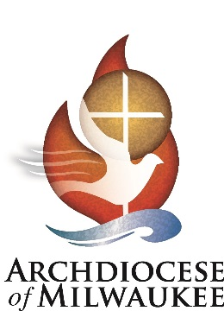

DATE:

INVOICE #: CEC2021-School Name

TO: Title Vendor
Street Address
City, State, Zip Code

NUMBER OF ATTENDEES | EVENT DESCRIPTION | COST/ATTENDEE | TOTAL
 | 2021 Catholic Educators Convention on behalf of  Name of School, October 8, 2021; sessions, general session and lunch.  2021 Catholic Educators Convention on behalf of Name of School, October 8, 2021; sessions only.  Please see attachments for attendee list and supporting documents. | $40  $25 | $  $
 |  | Subtotal: | $
 |  | TOTAL DUE: | $

Please make all checks payable to Archdiocese of Milwaukee.

If you have any questions concerning this invoice, contact Janelle Luther at 414-758-2256 or lutherj@archmil.org.

Thank you!

